Here are the teachers working in Acorns

Welcome to our Acorns classes at Millfields First School!

This is such an unusual time: usually, we would be welcoming you in to have a school lunch with us and story time sessions, to give you the opportunity to explore the classrooms and garden area at the beginning of a very exciting new journey.

However, things are a little different this year! So here are some photos of the adults who will help you: hopefully, this will help you recognise some faces when you do join us in September.

We’d love you to fill out the information below too: this can be done using drawings, grown-ups writing or photographs. This will help us learn all about you too!

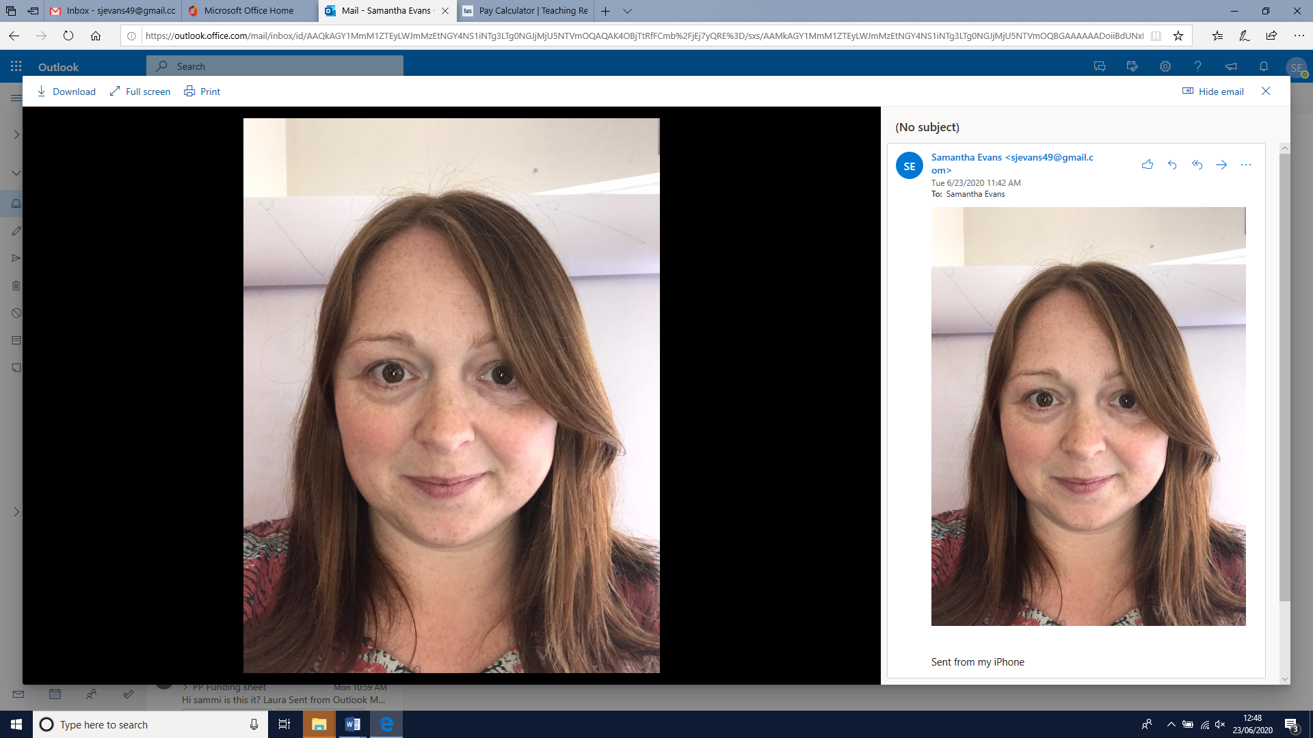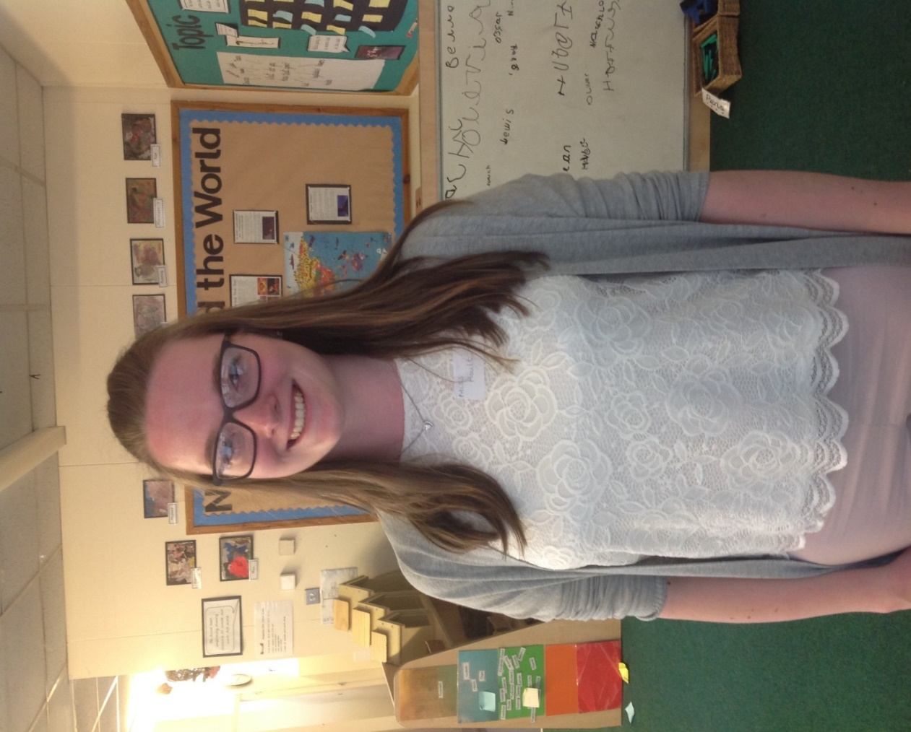

Miss Hoult

Mrs Watkins

These are other adults that help us in Acorns

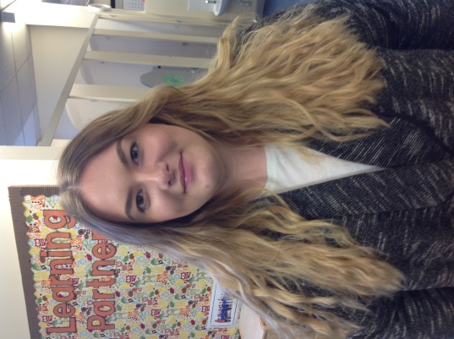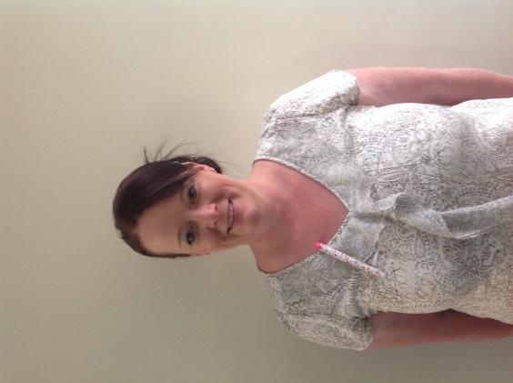

Miss Cullin

Mrs Cleaver

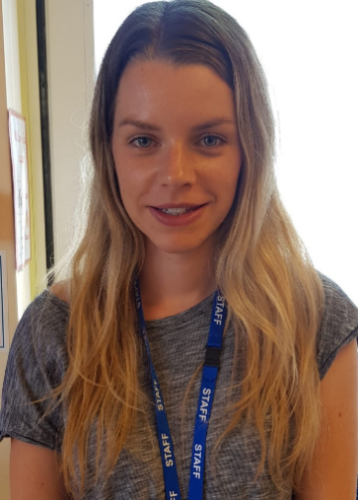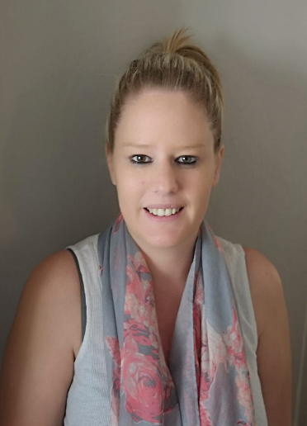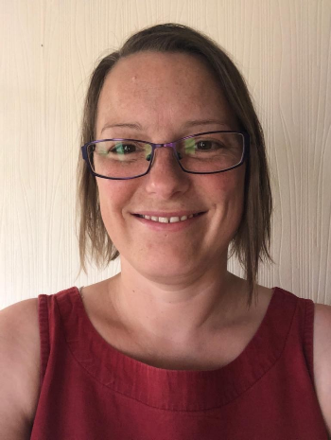

Miss Sheldon

Mrs Clarke

Mrs Verdon

**All about me**

We’d love to learn about you too.

Picture of me (Photograph or drawing)

Name:

**People who are important to me**

**My family**

**My special friends**

**Other people important to me**

**Things I would like you to know about me**

**I like**

**I don’t like**

**My favourite activities**

**My favourite rhymes and stories**

**My favourite toys**